**Mr. Visca’s: Calculus (Chpt 2.3)**

**Chpt 2 – Day 7 Continuity**

**Continuity at a Point:**

Interior Points:

A function y = f(x) is continuous at __________________________ of its domain if

End Points:

A function y = f(x) is continuous __________________ or is continuous ____________________ if

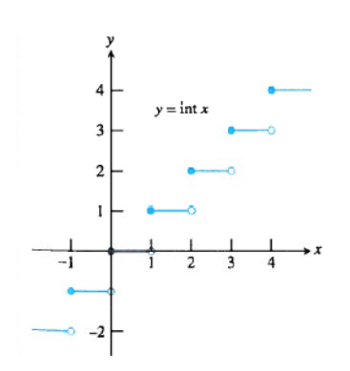

Is y = int x continuous at x = 3? Explain.

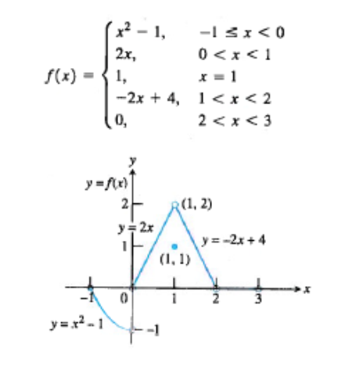

Does f(-1) exist?





Is f(x) continuous at x = -1?

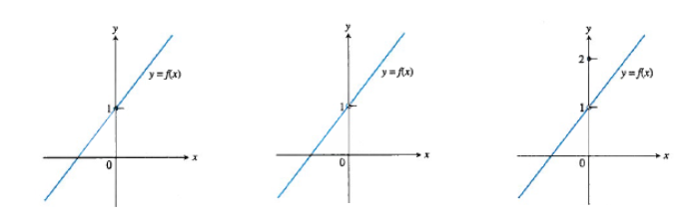**Identifying Discontinuity**

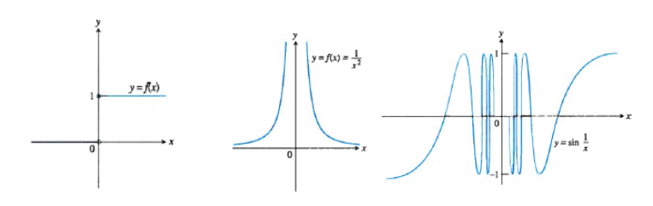

**Continuous Functions**

A function is **continuous on an interval**, if and only if it is continuous at _____________ on the interval.

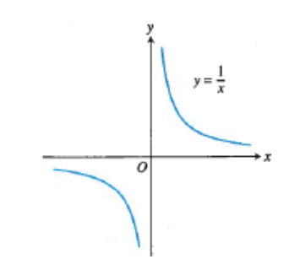A function is **continuous**, is one that is continuous at every point of its _______________

So, can a function be continuous AND have a point of discontinuity?

Is y = 1/x a continuous function?

How come?

Is there a point of discountinuity?

*HW: section 2.3*

*#s 1 - 18 odds only*